**Read Me**

**DC229862 CHENHONGDA**

**How to configure Eclipse PHP Development Tool(PDT) and XAMPP to run PHP**

**Project?**

You can follow the video step:

**https://www.youtube.com/watch?v=OE2DE5pXpmw&ab_channel=CodeFlyr**

**Also you can follow the below of my steps:**

**Go to “Help”, click “Install New Software”.**

**Available Software page: Type “Latest Eclipse Simultaneous Release -**

[**https://download.eclipse.org/releases/latest”**](https://download.eclipse.org/releases/latest)

Choose “**Programming Languages**” and find all “**PHP Development Tools(PDT)**”

then tick it to install.

After install then Open perspective: see PHP, successfully install.

**Create PHP Project using XAMPP.**

Choose the “Create project at an existing location” and Browse the directory:

/Application/XAMPP/xamppfiles/htdocs.(You should replace the actual path of the

htdocs file in your computer.)

**To run php file**:

Right click on index.php file ->Right Click “**Run As**” -> Click “**PHP Web Application**”

Click “OK”, then get the rendered page.

**How to create Database and Table?**

**Start the XAMPP connection first.**

**Go to http://localhost/phpmyadmin**

**Create an empty database first. Name “cart_system”.**

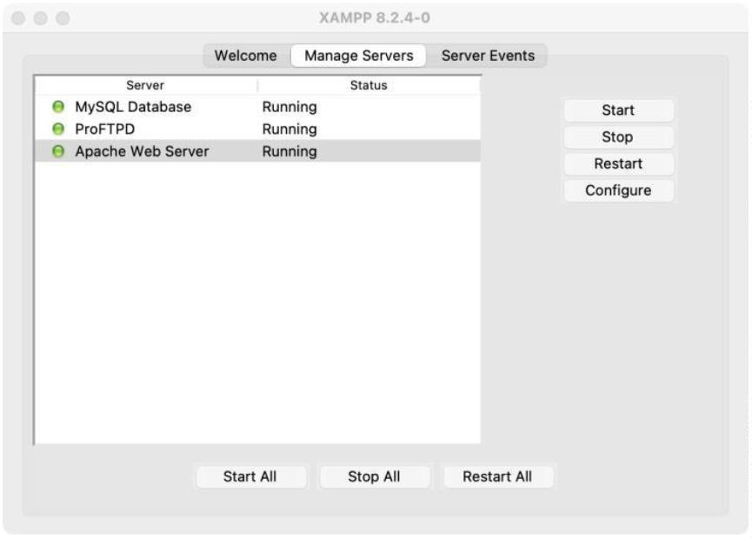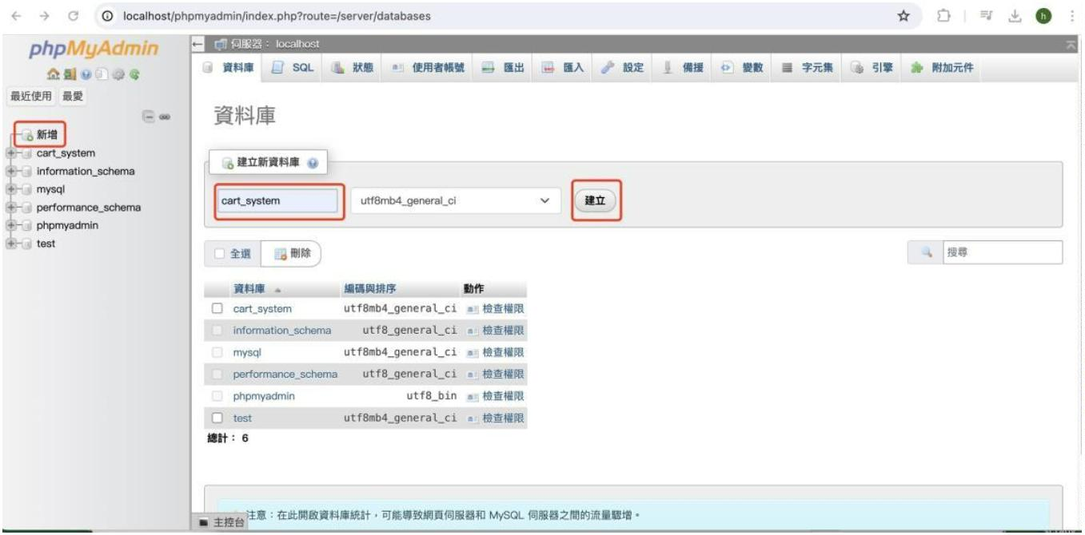

**Copy all the content in the “cart_system.sql”, then paste all the content on SQL of**

**phpMyAdmin and click “Execute”.**

Successfully imort the data.

